**INTRODUCTION**

The Sustainable Forestry Initiative® (SFI) [2022 Standards](https://forests.org/sfi-2022-standards/) include requirements that promote and conserve Forests with Exceptional Conservation Value (FECV), which includes critically imperiled (G1) and imperiled (G2) species. This fact sheet summarizes the analysis of FECV habitat within this ecoregion and provides habitat management recommendations that would benefit species potentially found here.

**HABITAT TYPES**

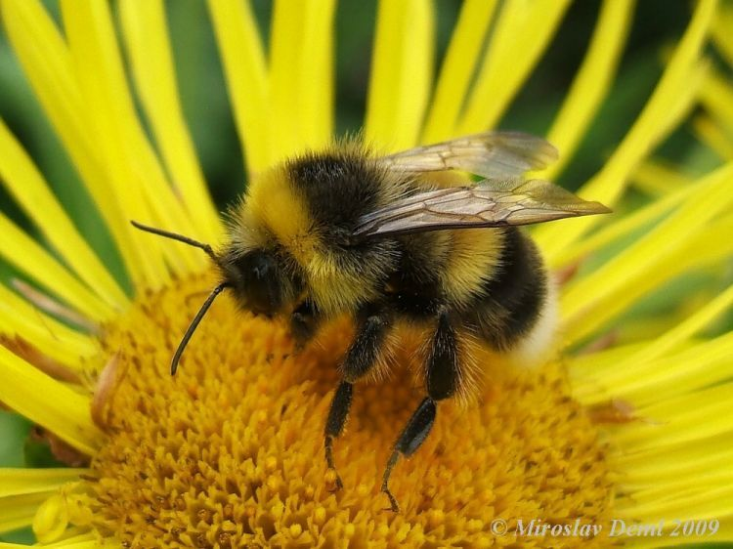**Suckley Cuckoo Bumble Bee**

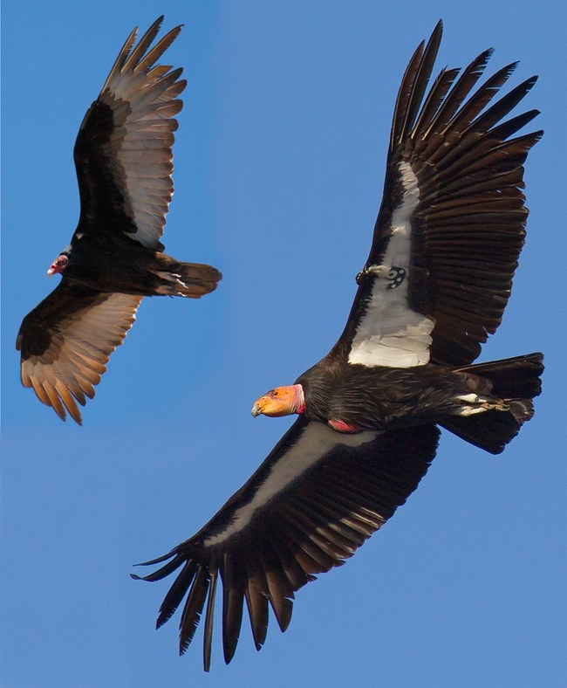

**California Condor**

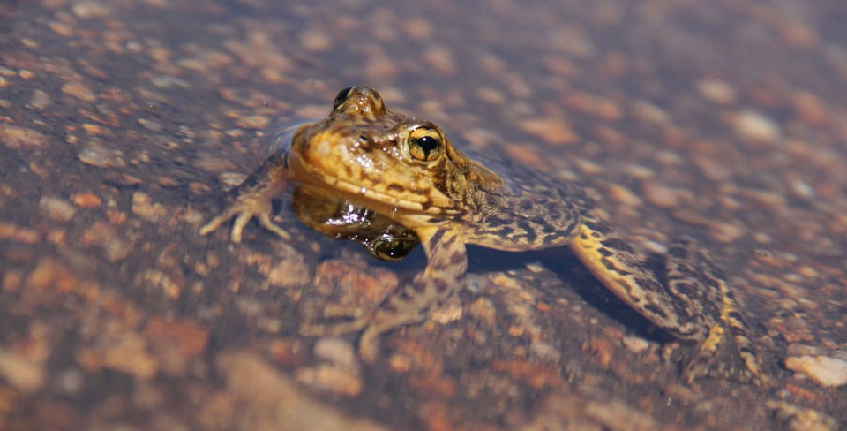

**Sierra Nevada   
Yellow-legged Frog**

* Mixed Conifer Forest
* Riparian/Streams/Wetlands/Temporary Pools
* Special Sites (Bare Rock/Talus, Barrens, Bog/Fen, Cliff, Forest Edge, Grassland, Savanna, Shrubland/Chapparal)

**MIXED CONIFER FOREST MANAGEMENT**

* Protect known locations
* Retain legacy trees, stumps, and logs
* Retain large diameter trees with cavities or broken tops
* Leave skips and gaps with dense shrub component
* Retain large slash into piles

**RIPARIAN/STREAMS/WETLANDS/TEMPORARY POOLS MANAGEMENT**

* Protect known locations
* Maintain well vegetated riparian buffers
* Plant a diversity of both hardwood and conifer trees
* Retain large diameter trees near streams, rivers and wetlands
* Buffer wetlands, springs, and headwater areas

**SPECIAL SITES MANAGEMENT**

* Protect known locations
* Maintain and buffer special sites
* Provide floral resources for sensitive bees

|  |  |  |  |
| --- | --- | --- | --- |
| **SCIENTIFIC NAME** | **COMMON NAME** | **HABITAT** | **STATUS** |
| *Haplodontium tehamense* | [Lassen Peak Copper Moss](https://explorer.natureserve.org/Taxon/ELEMENT_GLOBAL.2.123735) | Bare Rock/Talus | G2 |
| *Boechera constancei* | [Constance's Rockcress](https://explorer.natureserve.org/Taxon/ELEMENT_GLOBAL.2.134763) | Barrens | G2 |
| *Oreostemma elatum* | [Plumas Mountaincrown](https://explorer.natureserve.org/Taxon/ELEMENT_GLOBAL.2.150831) | Bog/Fen | G2 |
| *Bombus suckleyi* | [Suckley's Cuckoo Bumble Bee](https://explorer.natureserve.org/Taxon/ELEMENT_GLOBAL.2.819661) | Forest Edge | G2 |
| *Bombus franklini* | [Franklin Bumble Bee](https://explorer.natureserve.org/Taxon/ELEMENT_GLOBAL.2.109927) | Grassland | G1 |
| *Phacelia cookie* | [Cooke's Phacelia](https://explorer.natureserve.org/Taxon/ELEMENT_GLOBAL.2.146189) | Mixed Conifer Forest | G1 |
| *Gymnogyps californianus* | [California Condor](https://explorer.natureserve.org/Taxon/ELEMENT_GLOBAL.2.101273) | Mixed Conifer Forest | G1 |
| *Carex xerophila* | [Chaparral Sedge](https://explorer.natureserve.org/Taxon/ELEMENT_GLOBAL.2.964091) | Mixed Conifer Forest | G2 |
| *Rupertia hallii* | [Hall's Rupertia](https://explorer.natureserve.org/Taxon/ELEMENT_GLOBAL.2.139005) | Mixed Conifer Forest | G2 |
| *Allium jepsonii* | [Jepson's Onion](https://explorer.natureserve.org/Taxon/ELEMENT_GLOBAL.2.159138) | Mixed Conifer Forest | G2 |
| *Draba carnosula* | [Mt. Eddy Draba](https://explorer.natureserve.org/Taxon/ELEMENT_GLOBAL.2.154362) | Mixed Conifer Forest | G2 |
| *Monardella follettii* | [Serpentine Mountainbalm](https://explorer.natureserve.org/Taxon/ELEMENT_GLOBAL.2.149784) | Mixed Conifer Forest | G2 |
| *Campanula wilkinsiana* | [Wilkins' Harebell](https://explorer.natureserve.org/Taxon/ELEMENT_GLOBAL.2.136237) | Mixed Conifer Forest | G2 |
| [*Calochortus syntrophus*](https://explorer.natureserve.org/Taxon/ELEMENT_GLOBAL.2.144430) |  | Mixed Conifer Forest | G2 |
| *Pyrgulopsis archimedis* | [Archimedes Pyrg](https://explorer.natureserve.org/Taxon/ELEMENT_GLOBAL.2.115619) | Riparian/Streams | G1 |
| *Helisoma newberryi* | [Great Basin Ramshorn](https://explorer.natureserve.org/Taxon/ELEMENT_GLOBAL.2.115619) | Riparian/Streams | G1 |
| *Tuctoria greenei* | [Green's Awnless Orcutt Grass](https://explorer.natureserve.org/Taxon/ELEMENT_GLOBAL.2.144317) | Riparian/Streams | G1 |
| *Pisidium ultramontanum* | [Montane Peaclam](https://explorer.natureserve.org/Taxon/ELEMENT_GLOBAL.2.121316) | Riparian/Streams | G1 |
| *Hesperoleucus mitrulus* | [Northern Roach](https://explorer.natureserve.org/Taxon/ELEMENT_GLOBAL.2.101067) | Riparian/Streams | G1 |
| *Pacifastacus fortis* | [Shasta Crayfish](https://explorer.natureserve.org/Taxon/ELEMENT_GLOBAL.2.110563) | Riparian/Streams | G1 |
| *Rhyacophila spinata* | [Spiny Rhyacophilan Caddisfly](https://explorer.natureserve.org/Taxon/ELEMENT_GLOBAL.2.112855) | Riparian/Streams | G1 |
| *Desmona bethula* | [Amphibious Caddisfly](https://explorer.natureserve.org/Taxon/ELEMENT_GLOBAL.2.115619) | Riparian/Streams | G2 |
| *Colligyrus convexus* | [Canary Duskysnail](https://explorer.natureserve.org/Taxon/ELEMENT_GLOBAL.2.721219) | Riparian/Streams | G2 |
| *Ecclisomyia bilera* | [King's Creek Ecclisomyian Caddisfly](https://explorer.natureserve.org/Taxon/ELEMENT_GLOBAL.2.105585) | Riparian/Streams | G2 |
| *Lanx patelloides* | [Kneecap Lanx](https://explorer.natureserve.org/Taxon/ELEMENT_GLOBAL.2.105585) | Riparian/Streams | G2 |
| *Fluminicola seminalis* | [Nugget Pebblesnail](https://explorer.natureserve.org/Taxon/ELEMENT_GLOBAL.2.107872) | Riparian/Streams | G2 |
| *Monadenia infumata* | [Redwood Sideband](https://explorer.natureserve.org/Taxon/ELEMENT_GLOBAL.2.821157) | Riparian/Streams | G2 |
| *Cottus asperrimus* | [Rough Sculpin](https://explorer.natureserve.org/Taxon/ELEMENT_GLOBAL.2.104855) | Riparian/Streams | G2 |
| *Rana sierrae* | [Sierra Nevada Yellow-legged Frog](https://explorer.natureserve.org/Taxon/ELEMENT_GLOBAL.2.106312) | Riparian/Streams | G2 |
| *Pyrgulopsis eremica* | [Smoke Creek Pyrg](https://explorer.natureserve.org/Taxon/ELEMENT_GLOBAL.2.106312) | Riparian/Streams | G2 |
| *Juga acutifilosa* | [Topaz Juga](https://explorer.natureserve.org/Taxon/ELEMENT_GLOBAL.2.106312) | Riparian/Streams | G2 |
| *Sidalcea robusta* | [Butte County Checker-mallow](https://explorer.natureserve.org/Taxon/ELEMENT_GLOBAL.2.106312) | Savanna | G2 |
| *Packera layneae* | [Layne's Butterweed](https://explorer.natureserve.org/Taxon/ELEMENT_GLOBAL.2.141097) | Shrubland/Chaparral | G2 |
| *Trifolium piorkowskii* | [Piorkowski's Clover](https://explorer.natureserve.org/Taxon/ELEMENT_GLOBAL.2.1066061) | Temporary Pools | G2 |
| *Juncus leiospermus* | [Red Bluff Rush](https://explorer.natureserve.org/Taxon/ELEMENT_GLOBAL.2.148678) | Temporary Pools | G2 |
| *Orcuttia tenuis* | [Slender Orcutt Grass](https://explorer.natureserve.org/Taxon/ELEMENT_GLOBAL.2.155653) | Temporary Pools | G2 |
| *Juncus digitatus* | [Finger Rush](https://explorer.natureserve.org/Taxon/ELEMENT_GLOBAL.2.820811) | Wetland | G1 |
| *Gratiola heterosepala* | [Boggs Lake Hedge-hyssop](https://explorer.natureserve.org/Taxon/ELEMENT_GLOBAL.2.129926) | Wetland | G2 |
| *Epilobium oreganum* | [Oregon Willowherb](https://explorer.natureserve.org/Taxon/ELEMENT_GLOBAL.2.158466) | Wetland | G2 |
| *Cryptantha crinite* | [Silky Cryptantha](https://explorer.natureserve.org/Taxon/ELEMENT_GLOBAL.2.133549) | Wetland | G2 |

*\*Species links provided when available*

